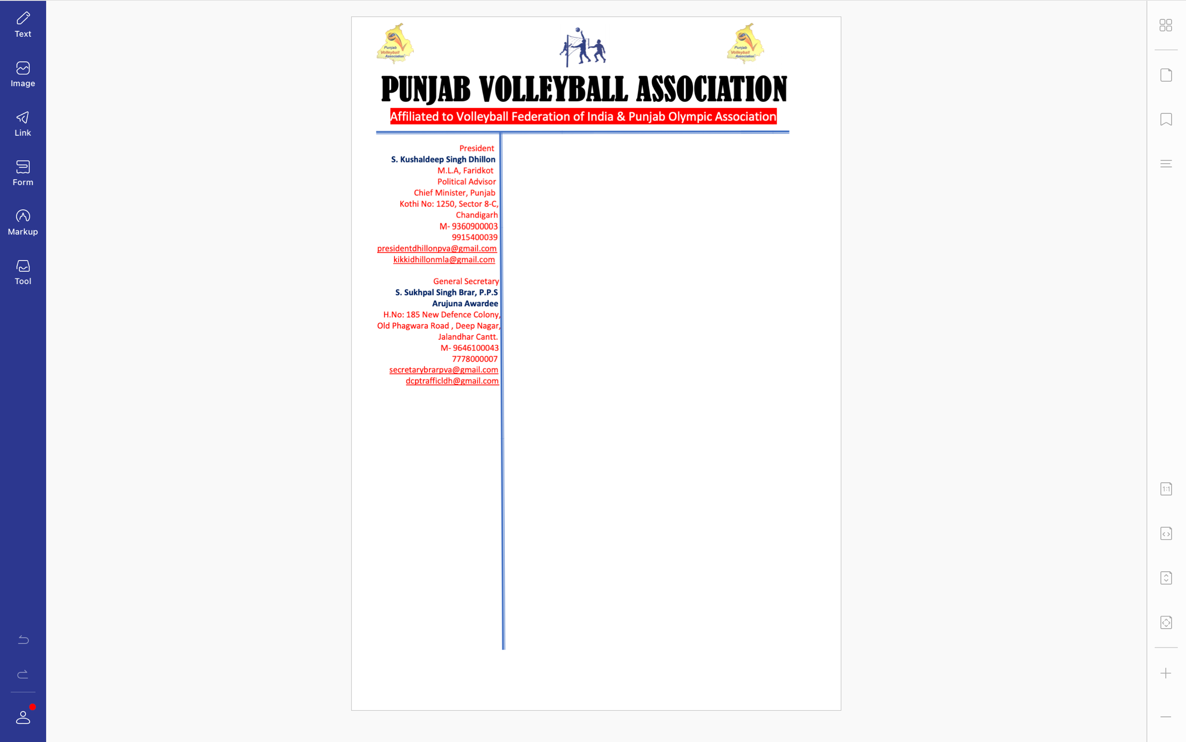



**Ref. PVA/BRAR/2021/Spl.-(2)/2521** Dated:25-10-2021

v`l:

ipRqpwl isMG

jnrl sk`qr

izlwH vwlIbwl AYsosIeySn, pitAwlw

ivSw: Awbzrvr leaux sbMDI

auoprokq ivSy sbMDI Awp jI nUM iliKAw jWdw hY ik izlwH sMgrUr dI izlwH vwlIbwl AYsosIeySn dI cOx imqI 29-10-2021 nUM SRI msqUAwxw swihb (sMgrUr) krvweI jw rhI hY[ ies iv`c Awp jI nUM pMjwb vwlIbwl AYsosIeySn v`loN bqOr Awbzrvr ifautI lgweI jWdI hY Aqy hdwieq kIqI jWdI hY ik cox inrp`K krvwaux dI pUrn izMmyvwrI Awp jI dI bxdI hY[ iqMn idnW dy AMdr cOx sbMDI irport pMjwb vwlIbwl AYsosIeySn dy pRDwn Aqy jnrl sk`qr nUM ilKqI qOr qy Byjx dI Kycl kIqI jwvy[

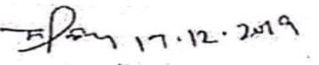

suKpwl isMG brwV, Arujnw AvwrfI

jnrl sk`qr